CENTRE FOR ADVANCE ILIZAROV RING FIXATOR SURGERY

About Us

Dr. Abhay Chandak has developed one of India's prestigious centers for Reconstructive Orthopedics Surgeries, using the Ilizarov technique. He has a pioneering role in popularizing Ilizarov Ring Fixator Surgery, in Northern India. This technique has revolutionized the orthopedic treatment, the world over. Chandak Hospital has now emerged as one of the most advanced Ilizarov Center of the country, equipped with latest instrumentation and latest medical gadgetry, where severely complicated cases from across the country are being treated successfully. The hospital prides over performing the Ilizarov surgery in approximately 800 patients in about ten years. The center specializes in the personalized care of these patients and has succeeded consistently in giving rewarding results, carving a special niche.

Dr.Abhay Chandak has carved a niche in the management of a plethora of Orthopedic related problems. All aspects of Ilizarov Techniques, such as limb lengthening, deformity correction, treatment of problem fractures, non-unions, bone gaps, poliomyelitis and foot deformities etc. is being extensively practiced.

The Chandak strives for the accuracy and flawlessness in the surgeries. They have resolved unto themselves to give the benefit of the technique to the farthest corner of our country. With their drive and enthusiasm, Chandak Hospital and Research Institute will become a haven for patients with broken bone and crippling disease.

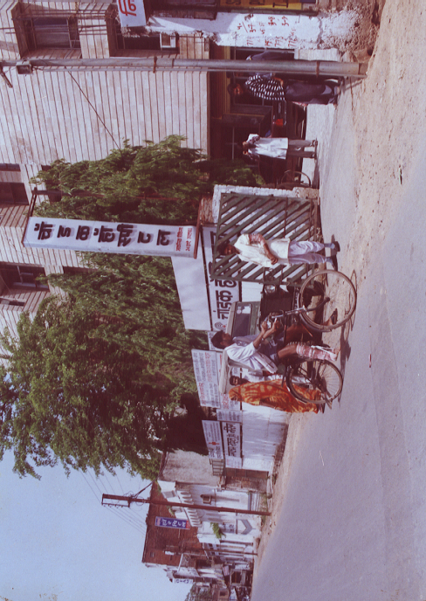

INTRODUCTION

In the fast life of today, where there is an incessant race against time and where success is gauged in terms of power and pelf, life affords little to rest and motion has become the hallmark of a successful person.

Patient who either sustain long bone fractures or undergo orthopedic procedure are often disabled for many month or even years. They may experience delay in osseous consolidation. Conventional methods of promoting bone union frequently do not work. Indeed, some techniques can cause serious pathologic changes. To make matters worse, protracted delay in healing compromise the function of the limb, thereby disabling the patient permanently.

The most frequently cited causes of disability in cases of long bone fractures include delayed consolidation, nonunion, malunion and joint contracture. For this reason, any technique that reduces both temporary and permanent disability following an injury should assume treat socio-economic importance, since trauma victims are frequently unproductive during convalescence.

In india number of patients affected by diseases like poliomyelitis, chronic osteomyelitis, tuberculosis, malnutrition which cause deformity and limb length discrepancy is increasing very steeply. It is estimated that there are about 10 million orthopaedically handicapped children and adults alike having deformities in their limbs, be it a deformity by birth like polio etc. or any other deformity caused at a later stage because of an accident or for any other reason. For such people Ilizarov method of treatment is the only answer where all other treatments fail to cure. It is said that Ilizarov method of treatment can cure up to eight hundred different types of bone deformities.

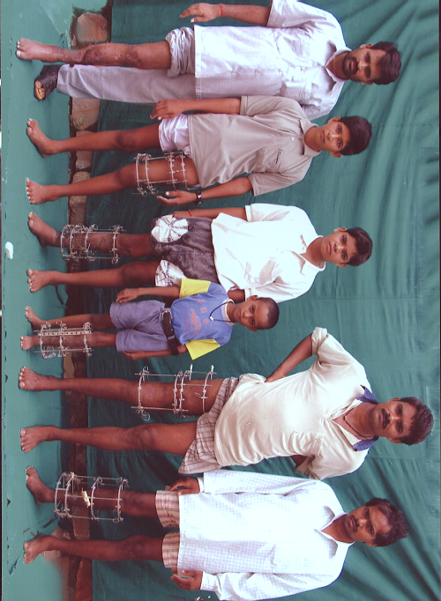

APPLICATION
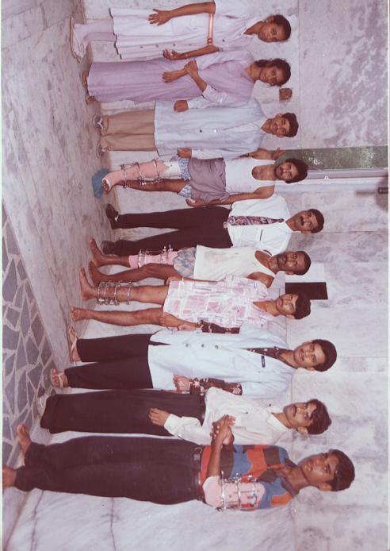

LIMB lengthening and deformity correction is a revolutionary concept developed by Dr. G.A Ilizarov, reversing the long-held belief that bone could not be regenerated. With this process, a bone that has been cut during surgery is gradually pulled apart, leading to new bone formation at the site of the lengthening. In this way, bone segments can be lengthened by 15 to 100 per cent of their original length. This method, known as Ilizarov operation, offers much better results than conventional orthopedic surgical techniques. In fact, Ilizarov operation is not one operation, but a method, where an external fixator is used to treat many different conditions. A customized apparatus is pre-constructed by the surgeon in preparation for each surgery. Using wires or pins, the apparatus is surgically attached to the affected limb.

One of the most useful application of Ilizarov method is, treatment of nonunion. In Ilizarov method usually no bone grafting is needed while by conventional methods of treatment bone grafting is must which leads to other incision, more blood, more pain, more bed rest etc. Today it is necessary, as it is in other treatment modalities, for the modern life style that the postoperative follow up period of the limb lengthening is comfortable and that the hospitalization time is short. The advantage of this technique is that patients can start functioning very early.

It is said that Ilizarov method of treatment can cure up to eight hundred different types of bone deformities. The Main cause of the wide use of Ilizarov's technique lies in the fact that we can resolve a complex of problems without principal changes of structure of the fixator, so this method is good for treatment of a lot of severe pathologies of loco-motor system, such as:
A few of them are listed below:

- Cosmetic bone lengthening (for example- to increase the height of dwarfs),
- Congenital and acquired limb shortening for equalizing leg lengths,
- Joints reconstruction,
- Nonunion fractures (infected and not infected, Osteomyelitis),
- Long bone defects, due to Chronic bone infection, severe open trauma (gunshot
fractures), tumors, in-born defects and others,
- limb deformities, with shortening or without it,
- Complicated and severe fractures management,
- Poliomyelitis: lengthening, thickening and fine shaping of shin and foot,
- Vascular disease, such as obliterating endarteritis and others

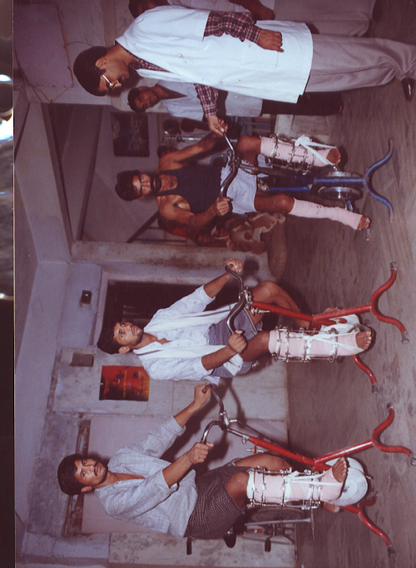

CASE PRESENTATION / PATIENT GALLERY

FREQUENTLY ASKED QUESTIONS

Q. What is bone lengthening?
A. Bone lengthening is procedure done on the affected bone/limb to increase the
length of the bone. It is done on patients whose limbs are shortened or
deformed either due to some accident, trauma or by birth. A small difference
in the leg lengths can have a significant functional effect on the patient,
whereas a large difference (greater than 7 cm) in arm is necessary to cause a
problem. This difference in the length of the limb is called LLD or Limb
Length Discrepancy.

Q. What are the problems caused by LLD (Limb Length Discrepancy)?
A. Long term effects of LLD are not very well documented. Some clinical problems
caused by Leg Length Discrepancy are as follows

- Foot Calluses.
- Increased energy consumption in walking, causing fatigue.
- Cosmetically unappealing limp.
- Low back pain.
- Scoliosis.
- Degenerative arthritis of the lumbar and sacroiliac joints.

Q. Who is a candidate for bone lengthening?
A. Patients with discrepancy of less than 1 inch should avoid bone lengthening
and go in for other alternatives. Bone lengthening is appropriate for
discrepancies between 1 inch (205 cm) and 18 inches (45 cm). These figures
are highly individual and depend from patient to patient.

Q. What are alternatives to bone lengthening?
A. A wide variety of treatment options exist for the patients with limb
discrepancy and the simplest form of treatment does not requires surgery.
Shoe Lift - A sole or a heel can be attached to or inserted inside the shoe
and can effectively level a difference of one to five centimeter. Beyond
this, the lift gets heavy, awkward and can cause problems such as ankle
sprains and fall.
Shortening the longer side - On the surface, this may sound
illogical and even dangerous, but bone shortening can be simple, safe and
effective way of equalizing leg length.

Limb shortening can be accomplished in one of two ways :
1- The growth plates can be arrested prematurely by epiphyseodesis.
2- The long bone can be shortened by resenting a segment of the bone

Q. What is congenital limb deficiency?
A. Congenital limb deficiency is a term used for a condition, present at birth,
that results in shortening, deformity or dysfunction of the limb.
There is commonly present additional deformities or deficiencies of the
surrounding tendons, muscles and joints.

Q. What is growth plate injury?
A Growth plates are disc shaped areas of a specialized cartilage located
near the ends of the bone in the growing child. When we stop growing taller
(in girls it is about 14 & years of age and in boys is 16) the growth plate
seal with bone and cease to add length to the bone. A fracture which occurs
through the growth plate may cause it to fuse prematurely, resulting in limb
length discrepancy. The younger the child at the time of injury, the greater
the shortening that may result.

Q. How long does the bone-lengthening take?
A. Limb lengthening duration is variable and dependent on many factors. It
includes the degree of deformity to be corrected, physical health, age of the
patient. In younger children the growth rate may be surprisingly excellent
where as in adults it is slow. For a normal limb lengthening the distraction
rate is One mm per day and it takes two to three times for actual maturation.

Q. How much does it hurts?
A. The simple answer is it depends on the tolerance of the patient.

Q. Why Chandak Hospital?
A. Chandak Hospital located in Gwalior, a very important city of India, it
provides excellent medical facilities at very affordable rates. Free
consultation is given to the needy and poor patients. The same kind of
llizarov treatment available in United States, Singapore, Russia, Bombay,
Delhi would cost up to three to five times more than in Chandak Hospital
Gwalior, with the same world-class facilities and excellent patient care
Chandak Hospital has been drawing patients from all around the country. Because of its quality services Chandak Hospital is also recognized by Government of India (Dept. of Health) for the treatment of Central Govt. Employees & their family member under Rule 2 (d) of the CS (MA) Rules, 1944.

Q. Where do I stay?
A. The patient’s stay at the hospital is surprisingly brief. The patient is
explained the lengthening procedure which is very simple and he can follow
the protocol at his home only. Further the patient is encouraged to walk with
full weight bearing next day after surgery.

GUEST COLUMN

YOUR QUERRY

TELL A FRIEND

DISCUSSION BOARD

